62nd IEEE Conference on Decision and Control
December 13-15, 2023
Marina Bay Sands,
Singapore
Website
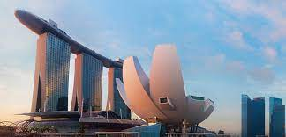

Sponsor and Exhibitor Prospectus

The Organizing Committee of the CDC 2023 invites you to Singapore for the 62nd IEEE Conference on Decision and Control (CDC 2023). The Conference will be held Wednesday through Friday, December 13-15, 2023 at the Marina Bay Sands. The conference will be preceded by technical workshops on Tuesday, December12, 2023.

The CDC is recognized as the premier scientific and engineering conference dedicated to the advancement of the theory and practice of systems and control. The CDC annually brings together an international community of researchers and practitioners in the field of automatic control to discuss new research results, perspectives on future developments, and innovative applications relevant to decision making, automatic control, and related areas.

The 62nd CDC will feature contributed and invited papers, as well as workshops and tutorial sessions.

The IEEE CDC is hosted by the IEEE Control Systems Society (CSS) in cooperation with the Society for Industrial and Applied Mathematics (SIAM), the Japanese Society for Instrument and Control Engineers (SICE) and Technical Committee on Control Theory and Application (TCCT) of the Chinese Automation Association.

Singapore is a sunny, tropical island in Southeast Asia, off the southern tip of the Malay Peninsula. Ideally positioned in Southeast Asia, where the rest of the region is just a hop, skip, and jump away, Singapore is a thriving metropolis offering world-class infrastructure, a fully integrated island-wide transport network, adynamic business environment, vibrant living spaces, and a rich culture largely influenced by the four major communities in Singapore with each offering different perspective of life in Singapore in terms of culture, religion, food, language, and history.

Accelerate your connections. To be sponsor and exhibitor at CDC 2023, contact us today at chenjie@bit.edu.cn / alberto.speranzon@gmail.com (sponsor) or xujun@ieee.org /tetu-sin@sophia.ac.jp (exhibitor).

Jie Chen and Alberto Speranzon.
Sponsorship Chairs
Jun Xu and Tielong Shen
Exhibits Chairs
Sponsorship Packages

Benefits | Diamond | Platinum | Gold | Silver | Bronze | Copper
Contribution (USD) | 30,000 | 10,000 | 5,000 | 3,000 | 1,500 | 1,000
Contribution (SGD)** | 42,000 | 14,000 | 7,000 | 4,200 | 2,100 | 1,400
Standard Booth (3m * 2m) | 2 | 1
Conference free registrations | 5 | 4 | 3 | 2 | 1
Invitations to VIP reception | 4 | 2 | 1
Acknowledged as sponsor for one social event (arranged with Organizing Committee) | o | o
One free conference workshop | o | o
* Sponsor special topic session (live) | o | o | o
Opportunities to meet online with attendees | o | o | o | o
Website and program acknowledgements | o | o | o | o | o | o
Flyer (ad) file into online program | o | o | o | o
Physical roll up banner (0.5m*1.5m) | o | o | o | o
Possibility of 1 additional booth for USD1,000 | o | o | o
Advertisement in the program book | o | o | o
Advertisement in the special promotion book (subject to change) | o | o | o | o | o | o
1. *: Due date is October 1, 2023 to be included in the final program book.
2. ** SGD option is only available to Singapore sponsors.

Important Dates
Item | Deadline (GMT)
Sponsorship Application and Remittance of Application Fee | October 1, 2023
Submission of the sponsor special topic | October 15, 2023
Submission of advertisement in the program book | October 15, 2023
Submission of advertisement in the special promotion book | October 15, 2023
Submission of flyer (ad) file | October 31, 2023

Sponsorship Application Form

Company Information
Company Information
Company Name:
Address:
URL:
Contact Person Information
Name: |  | Position:
Department: |  | Tel:
E-mail:

Sponsorship Selection
Sponsorship | Contribution
□ Diamond | USD30,000
□ Platinum | USD10,000
□ Gold | USD5,000
□ Silver | USD3,000
□ Bronze | USD1,500
□ Copper | USD1,000

Exhibition

Exhibiting at CDC 2023 is the most cost-effective way for a company, large or small, to gain exposure to the world’s leaders and future leaders in the field of automatic control and robotics.

Opportunities to showcase your products, publications, and organization. There will be a large exhibit space (1300sqm) for sponsors with coffee breaks taking place right there, to ensure maximum networking possibilities and exposure for exhibitors. Conference attendees can view attractive exhibitions throughout the course of the conference.

A special section is reserved for university and industry leaders to conduct recruitment activities using standard roll up banners in this exhibition.

Important Dates
Deadline for Exhibition Application and Remittance of Application Fee | By September 1, 2023
Exhibitor Set-up | December 12, 2023 (09:00am ~ 18:00pm)
Exhibition | December 13-15, 2023 (09:00am ~ 18:00pm)
Exhibitor Move-out | December 15, 2023 (18:00pm ~20:00pm)

Exhibition Booth
The organizer provides the following options.
Option | Description | USD
1 | Space only (per square meter) | 200 per square meter. Please contact exhibitor chair for 25m² or above
2 | Standard Booth (3m*2m) | 2200
3 | Standard table (0.8m*1m) | 200
4 | Standard roll up banner (0.5m*1m) | 250 (with print and banner)  100 (self-prepared)

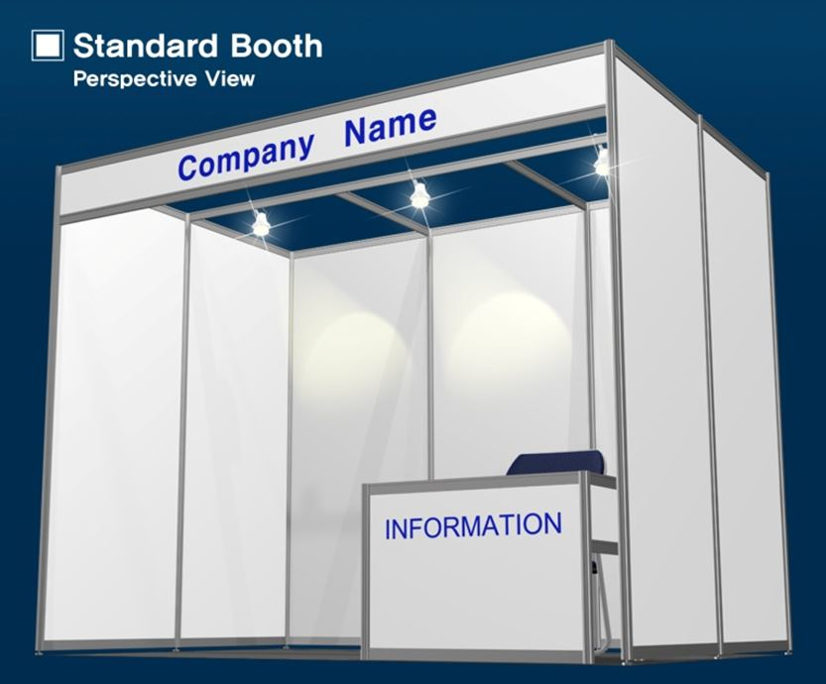 | ♦ Application Fee (per booth):  USD 2,200  ♦ Standard Booth (3m x 2m)  ♦ Company Name  ♦ Information Desk & Chair  ♦ 3 Spotlights (100W)  ♦ Fluorescent Lamp (40W)
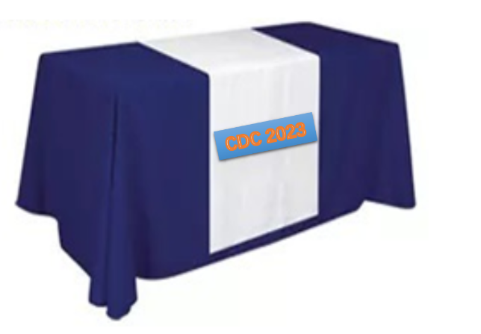 | Application Fee (Per table):  USD 200  ♦ Standard table (0.8m*1m)  ♦ Chair
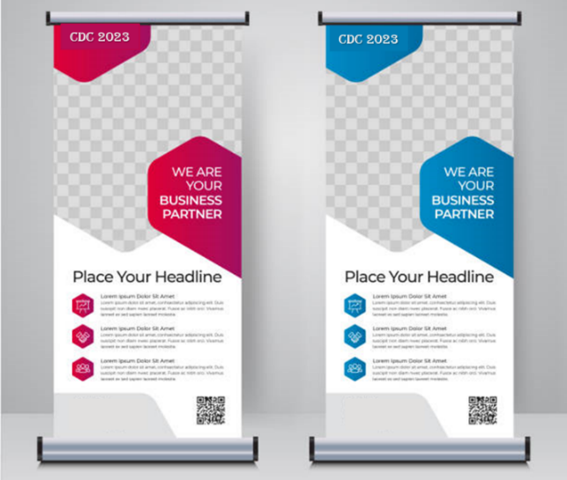 | Application Fee (Per banner):  USD 250 (full set)  ♦ Print (designed by exhibitors)  ♦ Banner & stand  USD 100 (self-prepared)  ♦ Space only

The layout of the exhibition hall is illustrated as follows (subject to change).
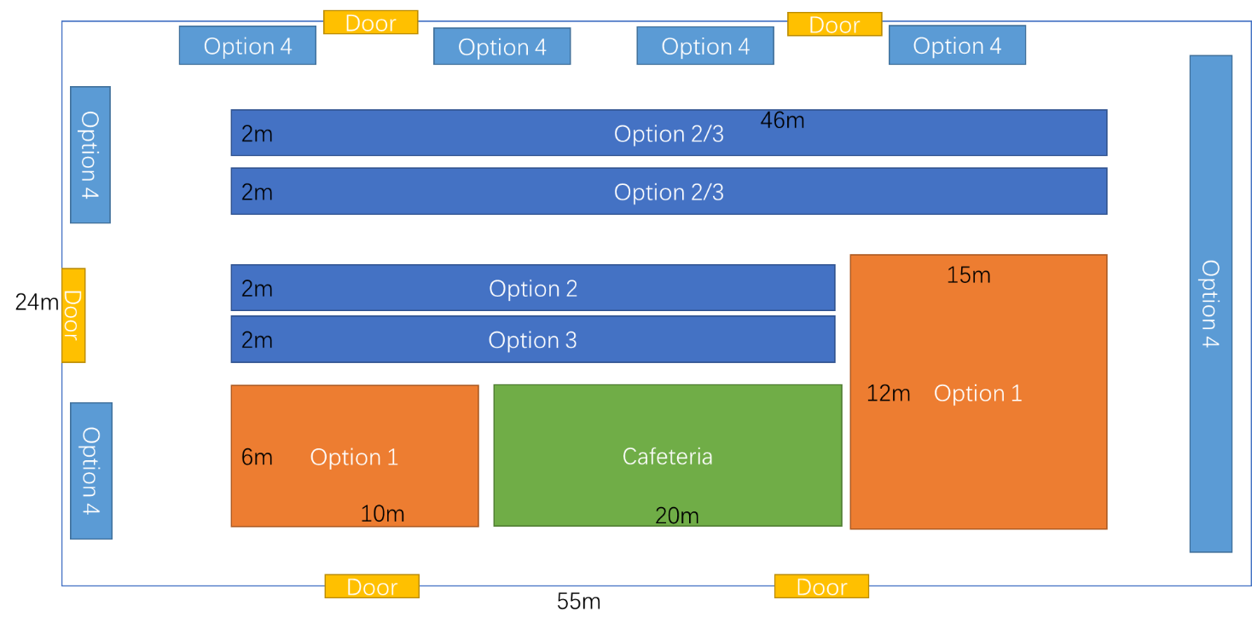
Priority and selection of booth space will be made according to application date, payment, applicant’s requests and available space.

Exhibition Application Form

Company Information
Company Information
Company Name:
Major Business Field:
Address:
URL:
Contact Person Information
Name: |  | Position:
Department: |  | Tel:
HP: |  | Fax:
E-mail:

Application Fee
Booth | USD2,200 per booth
 | Including modular booth (3m x 2m), company name, information desk & chair, 3 spotlights (100W), fluorescent lamp (40W) and consent
Total | Booth(s) * USD2,200 = USD

Table | USD200 per table
 | Including one table and one chair
Total | Table(s) * USD200 = USD

Banner | USD250/100 per banner
 | Full set including print and banner, or self-prepared banner and stand
Total | Full Set Banner(s) * USD250 = USD  Self-prepared Banner(s) * USD100 = USD

Space | USD200 per square meter
 | Space only
Total | Square meter(s) * USD200 = USD

Payment
Account Holder | IEEE CDC 2023 Organizing Committee
Account Number
Name of Bank
Bank Address
Swift Code

Priority and selection of booth space will be made according to application date, payment, applicant’s requests and available space.

CDC 2023 Secretariat
Tel: +65 - 6743 2523
E-mail: jasmine@jjayes.com; sec.singapore@ieee.org
Sponsor and Exhibitor Addendum

1. PURPOSES OF EXHIBITS: The purpose of the exhibits is to provide conference participants an opportunity to become aware of and to become knowledgeable about current and future technology, Instrumentation, software, and technical and educational literatures related to the general area of automatic control.

2. SPACE RENTAL: The exhibit space is located at the main lobby which is in a high traffic, public area of the conference space. The standard single booth rental space includes a floor area of approximately 3m x 2m. Information desk & chair, three spotlights (100W), fluorescent lamp (40W) and consent will be available for use. All other aspects of the exhibit are to be provided by the exhibitor. Exhibit space shall be rented from Tuesday, December 12, 2023 to Friday, December 15, 2020. The exhibitor should set up the exhibit at Tuesday, December 12, 2023 and remove after 18:00pm Thursday, December 15, 2023.

3. ASSIGNMENT OF SPACE: Platinum sponsors have priority placement of booth locations that will be negotiated in advance. All other booth locations will be assigned on a first come basis.

4. ARRANGEMENTS OF EXHIBITS: Exhibitor agrees to arrange exhibits so as not to obstruct the general view, nor to hide other exhibits. No display material exposing an unfinished surface to neighboring exhibits or aisles will be permitted.

5. ADVERTISING MATTER: The Organizing Committee reserves the right to refuse to permit distribution of souvenirs, advertising matter or anything else which it may consider objectionable. Distribution elsewhere than from exhibitor’s booth is forbidden.

6. SHIPPING: The exhibitor is responsible for all drayage fees associated with transport, storage, delivery and pick-up of all materials.

7. SAFETY PRECAUTIONS: Exhibitor agrees to take the necessary measures to safeguard visitors in the exhibit area from any hazards associated with exhibit equipment.

8. PAYMENT & CANCELLATION: Space shall be considered contracted upon payment per the above schedule and receipt of a signed application form. The actual payment for the cost must be completed within 14 days of submission of the application form.
If the exhibitor wishes to cancel their participation, a request must be submitted to the Organizing Committee in writing. Exhibitor cancellations and refunds will be administered as follows:
(a) For cancellation requests received before September 1, 2023, 70% of the fee will be refunded.
(b) There will be no refunds for cancellation requests received after September 1, 2023.

9. SECURITY: The Organizing Committee shall supply security for the exhibit space during the hours the conference registration desk is closed. The exhibitors will be responsible for safekeeping of their exhibit during all other hours.

10. REJECTIONS AND PENALTIES: The Organizing Committee reserves the right to restrict, reject, prohibit or eject any exhibit, in whole or in part, which because of noise, safety hazards or for other prudent reasons, becomes objectionable. If an exhibit or Exhibitor is rejected for violation of these rules and regulations, no return of rental fee shall be made.

11. INSURANCE AND LIABILITY: The Organizing Committee will use reasonable care to protect exhibitor against loss. However, they will not be liable to damage or loss to property of injury to exhibitor, his/her agents or employees, through theft, damage for fire, accident or other causes. Exhibitor should insure his/her property against such loss.

